**WGU's Four-Step Tool** (based on "[Six Steps to Thinking Systemically](https://thesystemsthinker.com/six-steps-to-thinking-systemically/)" by Michael Goodman and Richard Karash)

**STEP 1: Complete an Iceberg Tool for this case study.**

*The Iceberg Tool is a way to see how the structure (that is, the background of the case) ties together the individual events and the patterns and trends that emerge from recurring events. Using the Iceberg Tool allows you to see the basic facts and interconnections, an important first step.*

**Iceberg Tool to Understand Patterns and Structure**

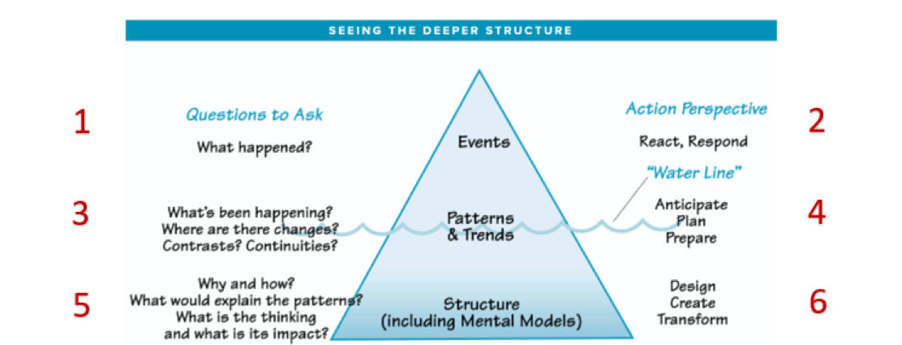

Iceberg tool shows events at the top, patterns and trends at the water line, structure near the bottom and less visible.

**Questions to Ask**

1. **What are the key events in this case study?**  
   According to the report on **Case Study 2**, James Memorial Hospital has adopted robots to perform specialized tasks with the intention of cutting costs and labor. Robot & AI technology is gaining new popularity and can now perform non-patient care tasks, including cleaning, sanitization, meal delivery, and kitchen help. The hospital is saving costs but is also experiencing a fall in patient admissions. One of the main concerns is that patients can interpret automated robotics as the reduction of the quality of care. George Jimenez, the CEO, attempts to calm the concern of patients by saying that automation, in fact, will not damage healthcare services.
2. **What patterns do you notice in the key events of this case study?**  
   The hospital is implementing AI autonomous technology to drastically reduce spending. The public at large views robot technology in hospitals as a quite touchy issue. Thus, due to these patients' critical condition and worry, their story changes, or they completely stay away from the hospital. The management says they mostly focus on cost reduction procedures, however, they deal with resistance and complaints mostly, from the new and the previous patients.
3. **What structure(s) explain the patterns of events in this case study?**

The Case Study 2 clearly highlights the problem with the hospital’s management infrastructure in the context of AI robots replacing human workers in order to cut operational costs.

In contrast, the human worker at the hospital might face chaos as the patients say they have no confidence in the hospital due to the fear of the system of robot patient care which disrupts their traditional atmosphere. Doctors must be made aware of the problem of AI dissatisfaction from the patient side as well as the adverse impact that this has on the hospital in order for them to be able to figure out the patients’ needs and woes, who are the main force behind the opposition here. Employees who are fired and dissatisfied patients are two of the most important reasons behind the overall resistance towards implementing the AI Robots. Therefore, this remains the biggest issue causing a sense of disbelief in the hospital management by the general public.

Moreover, there is no proper and explicit communication from the hospital department that conveys the actual purpose of the AI Robots deployment to the patient care which has increased the animosity towards the new disruptive adaptation of AI Robots in place of human care.

**STEP 2: Draw “Behavior Over Time” Diagrams.**(Use as many blank BOT graphs as necessary, given the case study)

*The BOT diagram helps you identify how human behavior plays out over a specific time period; here, the time is the period in which the case study occurred. It is best to group similar events or patterns together in a diagram; for example, you might create one BOT diagram showing the actions of different team members (all actions) and another for the investments made in marketing campaigns and the resulting return on those investments (all money).*

This **BOT diagram** shows how cost reduction, patient admissions, public perception, and staff morale change over time with the adoption of automation at James Memorial Hospital.

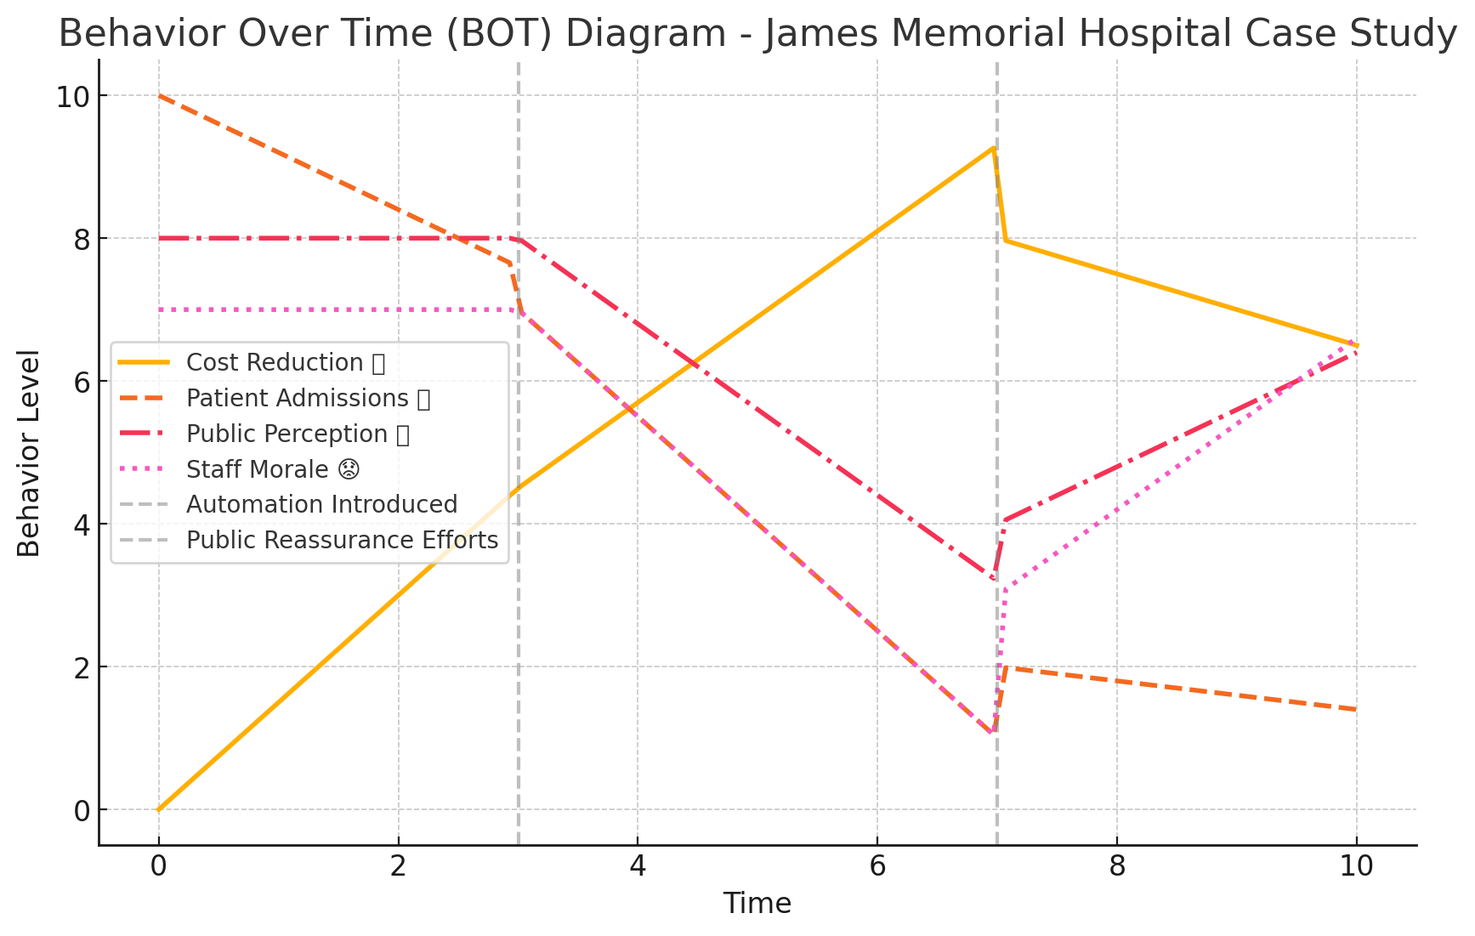

**1. Cost Reduction (Yellow Line)**

Before no automation (Time 0-3): Costs are relatively high.

Once the robotics appear (Time 3-7), Costs are lowered because robots gradually displace workers. Therefore, the hospital cuts down the operational and labor costs.

After public reassurance efforts (Time 7-10): Cost savings are still a thing, although the hospital's effectiveness may become a lesser issue with the public.

**2. Patient Admissions (Orange Dashed Line)**

Before no automation (Time 0-3): The number of patients admitted remains at a constant level.

When robotics are added (Time 3-7): This is not well received by patients with the noticeable drop in human care quality.

After reassurance information to the public (Time 7-10): To stabilize the admissions after cost reduction is common but to bring them back to their initial point would somewhat change the trajectory.

**3. Public Perception of Hospital Quality (Red Dash-Dot Line)**

Before no automation (Time 0-3): The hospital still has a high level of trust.

After the announcement of the robotics (Time 3-7): Losses in confidence due to lack of personal care are the major drawbacks of this kind of technological development.

After public reassurance efforts (Time 7-10): Perception is getting better but not enough to get back to the old level of confidence.

**4. Staff Morale (Pink Dotted Line)**

Before automation (Time 0-3): Staff morale remains unchanged.  
After automation introduction (Time 3-7): Morale among the employees is falling as they are unsettled about whether they will lose their jobs or not.  
After public reassurance efforts (Time 7-10): Morale of the hospital's team is moving toward better as the staff members understand that robots help them but not replace them.

**Overall Conclusion**

Automation reduces costs (success).However, patient admissions along with public trust are initially down (challenge). Hospital has to have clear information to regain the trust of the public ( necessary action).Staff morale is on the low phase with a subsequent upturn (can be tackled through adequate training).

**STEP 3: Select the systems archetype that best fits the case study.**You may refer to Section 2, Lesson 2.1.

*The value of the eight systems archetypes is that they represent common problems within systems. If you can find an archetype that fits the system and the problem(s) you are confronting, you can use established ideas for dealing with the problem(s).*

*Examine each archetype carefully, comparing its causal loop diagram and text description with the given case study to see which one is the best fit.*

1. **Which archetype did you select?**  
   I chose the Shifting the Burden archetype, which satisfies the criteria for Case Study 2 that I have selected.
2. **Why does this archetype best fit the given case study? Explain how its causal loop diagram and text description match up with the facts of the case study.**

The hospital is addressing the fact that operational costs are going up by going to AI automation but avoiding other options that may be less disruptive. One of this approach's apparent convenient solutions is the implementation of AI Robots, which causes paranoia and a negative atmosphere for patients. The overdependence on AI Robots might take the unbearable task of care off the humans, which would result in a possible decrease in the long-term quality of the hospital. The hospital's approach of not addressing the inherent operational inefficiencies while introducing a quick fix to address them, is the main reason for the long-run complications can as such result in a situation of development and perpetuation of problems.

1. **What is the main problem that needs to be addressed in this case study?**  
   The main issue at the moment is the worry concerning the AI automation that would decrease the humane touch in nursing care. The public's opinion of AI robots as the future of human care was supported and thus this may result in a patient's mistrust which may, in turn, lead to a drop in hospital reputation and thus healthcare competitiveness.

**STEP 4: Generate a solution to the problem.**

*Systems thinking is a mindset and a process focused on identifying and solving problems. Without problems, there is little need to think systemically. In this step, you consider a full range of possible solutions and select the best one.*

1. **What solution do you propose for the problem in this case study?**  
   My personal solution would be to implement a hybrid model where AI automation enhances, along with, rather than replaces, human interaction. The management should launch a public awareness campaign to properly create awareness among the patients on how robots assist, rather than replace, the traditional human staff. The hospital management should involve hospital staff and patient ombudsman groups in designing automation policies to ensure quality care remains untampered. The hospital should also provide staff training programs to integrate AI robotics effectively without losing the human touch and Monitor patient satisfaction reviews accordingly.
2. **What are the strengths of this solution?**  
   This solution blends savings and security. It balances cost reduction while maintaining patients’ trust.  
   It also ensures that the patients feel satisfied and comfortable with the AI automation as it retains the human aspect of care and also aligns with the long-term industry trends of moving to AI and Automation without the jerky immediate backlash from the patients and public in general.  
   Furthermore, it engages the staff with AI robotics and thus reduces the resistance to a full change.
3. **What are the challenges of this solution?**  
   Even though this solution is better than the previous one, it is still hard in terms of training and public relations.

On one hand, the hybrid approach may not only be perfect as far as alleviating the patients' fears but also the delay of the situation to turn into a more favorable one even in the end, is also a thing to fear for

Moreover, the procedure is a continual evaluation and improvement stance; it will also contain the feedbacks from the patients and the staff, and there should also be the slow changes as they become familiar with the new AI-based human caring system.

1. **What other alternatives did you consider AND why is your selected solution superior to each of them?**I considered 2 scenarios both of which I had to reject.  
   1) Full Automation & AI Expansion - I rejected this because it would worsen the public resistance issue rather than build upon it.  
   2) Reverting to Traditional Operations - I rejected this idea because it overlooks and ignores the immediate financial necessity of operational cost reduction in order to survive the rising costs to maintain and preserve the hospital.
2. **What do you project the impact of your proposed solution will be on the overall system described in this case study?**  
   My proposition would improve the public perception of AI Automation deployment along with human assistance, which would be conveyed to the patients through a transparent black-and-white type of communication and hands-on education. It would also balance out the cost reduction with improved and maintain the already existing patients’ trust and satisfaction ratings of the hospital overall.  
   It would also increase the hospital’s competitiveness without compromising service quality while also reducing the operation costs in the long term.  
   It would also result in a sustainable long-term adaptation of AI Automation, especially when the patients are more than comfortable getting used to the technological advancements in healthcare and interactions with the robots in general.